**How to Install Express Application Using Express Generator Tool**

October 29, 2020 By [Md Nurullah](https://codingstatus.com/author/noor/) [2 Comments](https://codingstatus.com/how-to-install-express-application-using-express-generator-tool/#comments)

🡺 SOURCE: https://codingstatus.com/how-to-install-express-application-using-express-generator-tool/

**Install Express Application:**This tutorial will help you to create a basic structure of Express js. If you are going to develop web applications using express js, you should create a basic structure of express. So that you can easily develop your web application. Even you will get a basic demo of routing, static files & views folder. On the basis of these demos, you will be able to create other folders, files & coding scripts according to your project requirement.

**Contents**[[show](https://codingstatus.com/how-to-install-express-application-using-express-generator-tool/)]

**Express Generator Tool**

Express Generator Tool provides an environment to quickly create a basic structure of express. You can read more about it  through the official website [expressjs.com](https://expressjs.com/en/starter/generator.html)

Before installing the express app, Node.js & NPM  must be already installed on your computer or laptop.

**How to Install Express Application**

Before Installing Express Application, Configure the following points –

* First of all, Make Sure that Node.js was already installed on your computer/laptop
* Create a Project Folder like myproject in D drive. You can create it in another drive

**1. Install Express Generator**

First of all, open the command terminator and go to myproject folder directory using the command –

D:\**>** cd myproject

After that, Install the Express  generator using the following command line

D:\myproject**>** npm install -g express-generator

**2. Install Express Application**

Run the following command to install the express application.

npx express --view=ejs nodeapp

In the above command, ejs is a template engine of the express and nodeapp is the root folder of the created express.

After running the above command, you will get the following instructions

PS D:\myproject**>** npx express --view=ejs nodeapp

create : nodeapp\

create : nodeapp\**public**\

create : nodeapp\**public**\javascripts\

create : nodeapp\**public**\images\

create : nodeapp\**public**\stylesheets\

create : nodeapp\**public**\stylesheets\style.css

create : nodeapp\routes\

create : nodeapp\routes\index.js

create : nodeapp\routes\users.js

create : nodeapp\views\

create : nodeapp\views\error.ejs

create : nodeapp\views\index.ejs

create : nodeapp\app.js

create : nodeapp\**package**.json

create : nodeapp\bin\

create : nodeapp\bin\www

change directory:

**>** cd nodeapp

install dependencies:

**>** npm install

run the app:

**>** SET DEBUG=nodeapp:* & npm start

**3. Install Dependencies**

Go to the created root folder myapp  by running the following command

PS D:\myproject**>**cd nodeapp

Install dependencies  using the following command

PS D:\myproject**>**nodeapp **>**npm install

**5. Know about Express Application Structure**

After configuring the above steps, you will get the following folder structure of Express Application. So, Before start coding with it, you should know about its necessary files –

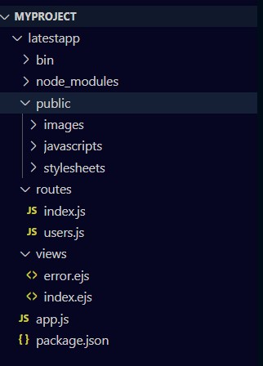

**4. Run Express Application**

First, run the following command to start Node.js Server

npm start

After getting started the server, Run your Express App by entering the following Port in your browser.

http://localhost:3000/

**My Suggestion**

Dear Developer, I hope you have learned how to install the express application using the express-generator. Now, you can easily develop projects using express. So, continue to visit my website, I will share more Node.js & express.js tutorials for you.

If you have any questions & suggestions related to this article or the web technology coding field, You should ask me through the below comment box.

**Thanks** for reading this tutorial…